## Portals:

-><https://apps.harman.com/Employee/Info/Basic/> -use for emp info.

-><https://harmanhub.net/about/tools/Pages/default.aspx> - all portal lists.

C:\LandisGyr\WareUI\ui-frame\src

# Client – LandisGyr

Printers config:

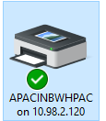

Should connect to above printer.

Then go to printer any floor and inter PIN: 182329 (Check in harman mail for PIN)

Credentials:

ThangalB N7k6JBIi

Thangalla.bharath@landisgyr.com

l

### Steps to vadilate client credentials:

1. Go to ’ [https://mfa.landisgyr.com](https://mfa.landisgyr.com/) ’ then go to mobile and update
2. Now download PULSE SECURE – enter Name” Landisgyr & server URL: ’ [https://vpn.landisgyr.com](https://vpn.landisgyr.com/)’
3. Now it will ask user name and pass- enter user name= landisgyr mail id and pass
4. If issues re-try or go to <https://vpn.landisgyr.com>
5. Now check ’ <https://wiki.landisgyr.net/>’ – working or not, if not get permision.
6. Now check ’ [https://gerrit-eu.landisgyr.net](https://gerrit-eu.landisgyr.net/)’

**Server url:**

<http://fijyvvrapp07.eu.bm.net/AIMUiFrame/en/meteringpoints>

<http://fijyvvrapp11.eu.bm.net/AIMUiFrame/>

fijyvvrapp11 (aimapptest11/password1)

# id/pass: wareui/wareui or mika/mikamika

# Git Extension setup:-

***********************

1. Got project folder where we need project ->

**Cmd:** git config - -global user.name ”Bharath T”

Git config - -global user.email [thangalla.bharath@landisgyr.com](mailto:thangalla.bharath@landisgyr.com)

Git config - -global tgit.logwidthmarker 72 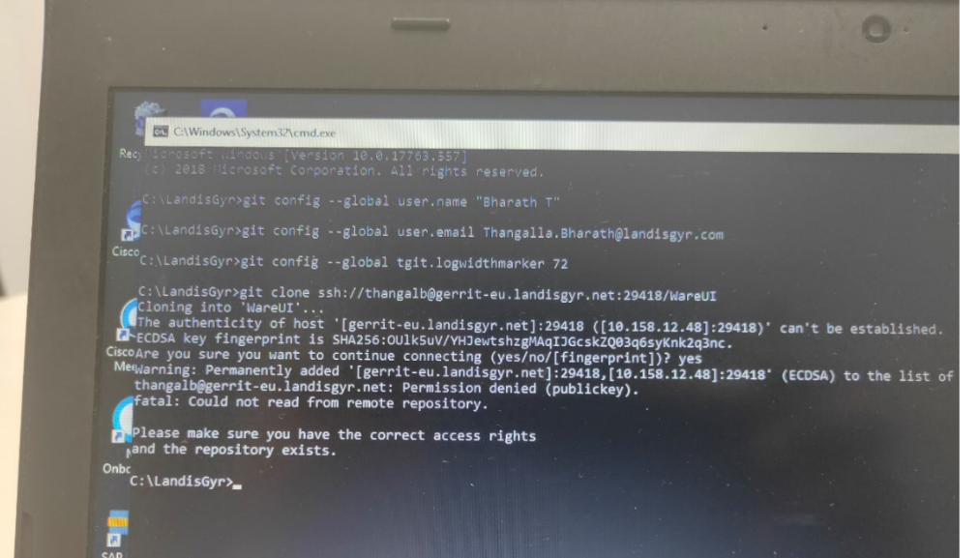

Now we have to do clone, but SSH key setup not done, so we have do that before clone.

1. Setup for SSH key
   1. Open command prompt as Administrator.
   2. **Cmd:**  ssh-keygen
   3. Hint: C:\Users\TBharath\.ssh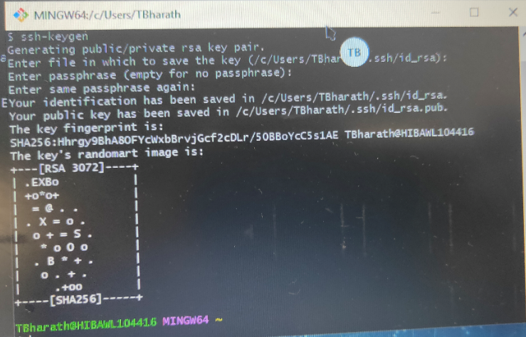

C. create text file- nameit ”config” – inside paste below

Host gerrit-eu.landisgyr.net  
User ThangalB  
Port 29418

1. Now SSH key generated, we have to set it on ’ [https://gerrit-eu.landisgyr.net](https://gerrit-eu.landisgyr.net/)’ - > settings - > ssh public key – ’add new’ -> 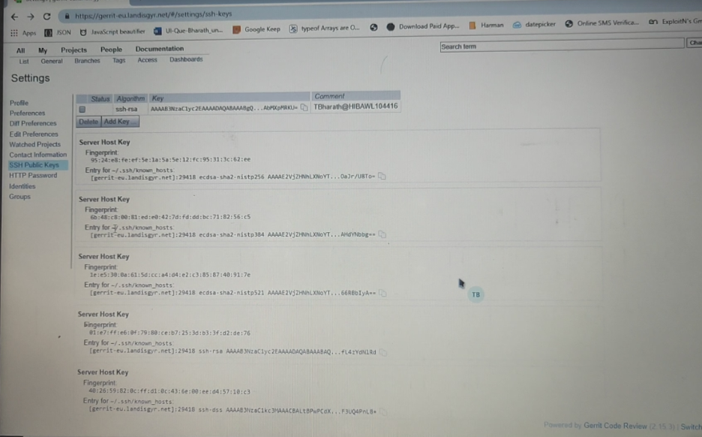
2. Nowgettit - > project url(or search: wareUI ->in project lists) - > click SSH - > copy - >**CMD:** git clone ssh://thangalb@gerrit-eu.landisgyr.net:29418/WareUI
3. Now do below steps - >



* 1. ’commit-msg’ in above file we have to paste it on ’ C:\LandisGyr\WareUI\.git\hooks’ – in project

1. Open GIT EXT - > SSH -> select OTHER SSH CLIENT - > Paste below path - > ’ C:\Program Files\Git\usr\bin\ssh.exe’ – and select that file too -> OK -> WOW – DONE 😊

## Code commit tips:

We have to run two commands before pushing

**Cmd:** npm run lint & npm run build -en & main **cmd**: ng build --configuration=fi

1. PUSH to only refs/for/master, not dirrect to maste
2. Commit message should be in stucture, check below image 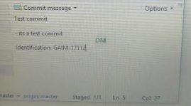
3. If we get review tasks - while committing that review, we have to tick that ’anmed commit’

->2Ways to get latest code to local(here fetch/fetch all not get latest in local), these two steps have to do to get latest in local—this is for my machine.

1. Take backup- step-1(if any files are their to commit/push-)
   1. Now fetch all/fetch – step-2
   2. Right click on ’master-origin/master’(here only)
   3. Click ’merge’-step-3 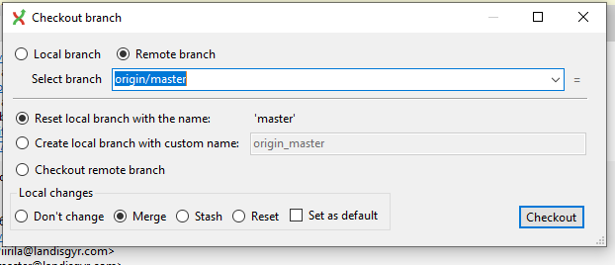
   4. Click-’Checkout’ btn
2. if thier is no files to commit/push
   1. **cmd:** git rebase or try at own risk on git ext app.

# Changes to run application:

********************************  
->C:\LandisGyr\WareUI\backend-dev-proxy -> **cmd:** npm install

->go to c;/windows/system32/drivers/etc or search ’HOSTS’ in local C disk. & past below things on bottom of that file.

10.158.12.89 fijyvvrapp01.eu.bm.net  
10.158.40.61 fijyvvrapp09.eu.bm.net  
10.158.12.13 fijyvvrapp07.eu.bm.net  
10.158.12.19 fijyvvraimbl11.eu.bm.net  
10.158.12.111 fijyvvrcis07.eu.bm.net

->Multi login VPN url: vpnus.landisgyr.com

## Changing files

1. C:\LandisGyr\WareUI\backend-dev-proxy\.env.example-07
2. C:\LandisGyr\WareUI\ui-frame\src\environments\environment.ts
3. C:\LandisGyr\WareUI\backend-dev-proxy\src\constants\index.ts
4. In backend index.ts->  file changed
5. In backend ’ \.env.example-07’- remove every thing and copy ’ \.env.example-01’ & past in 07
6. In ui- ‘\environment.ts’ –
7. backend_api_prefix: "http://fijyvvrapp01.eu.bm.net/AIMWare/rs",

**App11 Settings**

After updating the environment.ts you also need to start the ui with command

npm run start-app11

​

[Sorry, I actually thought that you meant after setting the backend to make requests for the app11 server.

​

What needs to be done for making requests to app11 are:

1. Make .env file in the backend-dev-proxy folder and copy contents of the .env-example-11 file into it
2. Start the ui with command npm run start-app11

​

(do not make changes directly to the index.ts file in the backend-dev folder or to the environment.ts file)

​

That .env file in the backend-dev-proxy folder is local file for development and it is not meant to be added to Git (it is in the .gitignore file).

​

Files .env-example-01, .env-example-07 and .env-example-11 contain needed settings for each server and the contents of the needed one should be copied into the .env file for development. If there is no .env file, then 07 is used.

**App01 Settings**

in back end - src > constant > index.ts change below things

*fijyvvraimbl11.eu.bm.net* to

*fijyvvrapp09.eu.bm.net*

credentials : app01/password

or try same credentials if not works above

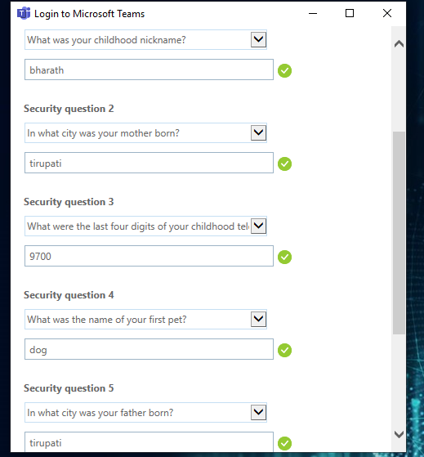

->question 5. Answer .) chicken